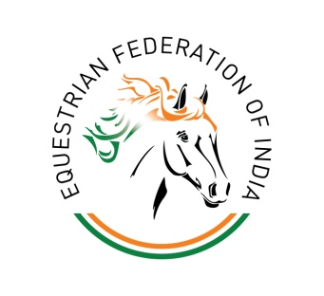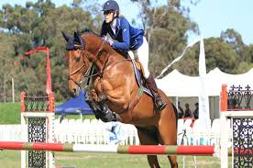

PROSPECTUS

1st REGIONAL EQUESTRIAN LEAGUE (REL)
&
The Second CHETAK Horse Show
5th Oct 2018 – 7th Oct, 2018

Organised By
CHETAK EQUESTRIAN SPORT ACADEMY
(CESA)

Venue
CHETAK EQUESTRIAN SPORT ACADEMY
(CESA)

Sec-57, Sushant Look-3, Golf Course Ext. Road, Near Rajdhani
Real Estate, Gurugram (HR) Mob:9999014448 or 8770477937

1st REGIONAL EQUESTRIAN LEAGUE (REL) & CHETAK HORSE SHOW)
PROGRAMME
05th October, 2018 – 07October, 2018 - Time: 0900 hrs to 1800 hrs
Draw of Lots for Starting Order for all events will be held on 07.10.18 at 1600 hrs at Show Office
Sno. | Event | Category | Time | Date
1 | DRESSAGE  (REL/Chetak Horse Show ) | Children II (10 to 12 yrs) | 0900 hrs  to  1300 hrs | 07th  OCTOBER  2018
1 | DRESSAGE  (REL/Chetak Horse Show ) | Childen I (12 to 14 yrs) | 0900 hrs  to  1300 hrs | 07th  OCTOBER  2018
1 | DRESSAGE  (REL/Chetak Horse Show ) | Junior (14 to 18 yrs) | 0900 hrs  to  1300 hrs | 07th  OCTOBER  2018
2 | SHOW JUMPING  (REL/Chetak Horse Show) | Children II (10 to 12 yrs) | 1500 hrs  to  1800 hrs | 07th  OCTOBER  2018
2 | SHOW JUMPING  (REL/Chetak Horse Show) | Children I (12 to 14 yrs) | 1500 hrs  to  1800 hrs | 07th  OCTOBER  2018
2 | SHOW JUMPING  (REL/Chetak Horse Show) | Junior (14 to 18 yrs) | 1500 hrs  to  1800 hrs | 07th  OCTOBER  2018
DAY - BREAK
1 | TENT PEGGING  (REL/ Chetak Horse Show) | Seniors | 0900 hrs  to  1300 hrs | 06th  OCTOBER  2018
2 | SHOW JUMPING  REL/ Chetak Horse Show) | Seniors  NOVICE & Gde-III | 0900 hrs  to  1300 hrs | 06th  OCTOBER  2018
3 | SHOW JUMPING Normal  (Chetak Horse Show) | Open (90 cms to 120 cms) | 1500 hrs  to  1700 hrs | 06th  OCTOBER  2018
4 | HACKS  (TSEA) | Children II (10 to 12 yrs) | 1500 hrs  to  1700 hrs | 06th  OCTOBER  2018
4 | HACKS  (TSEA) | Children I (12 to 14 yrs) | 1500 hrs  to  1700 hrs | 06th  OCTOBER  2018
4 | HACKS  (TSEA) | Junior (14 to 18 yrs) | 1500 hrs  to  1700 hrs | 06th  OCTOBER  2018
4 | HACKS  (TSEA) | Seniors | 1500 hrs  to  1700 hrs | 06th  OCTOBER  2018
Arrival of Chief Guest around 1600 hrs |  |  |  | 06th  OCTOBER  2018
Prize Distribution at 1700 hrs |  |  |  | 06th  OCTOBER  2018
Dress Code to be strictly followed for all events as per the EFI Guidelines
Birth Certificate is mandatory
MINIMUM ELIGIBILITY REQUIREMENT (MER REL)

Ser No | Discipline | MER | No of  MERs required | Remarks
1. | Show Jumping
1. | Seniors | Max 08 penalties  excluding time penalties  in 01 round | 02 | Same horse-rider combination needs to achieve MER
1. | Juniors  Children I  Children II | Max 08 penalties  excluding time penalties  in 01 round | 02 | MER is only for the rider, not for the combination
2. | Dressage
2. | Juniors  Children I  Children II | Min 57% score in REL | 02 | MER is only for the rider, not for the combination
3. | Tent Pegging | - Three run with Lance  - Two run on 4cm Peg  - One run on 2.5cm Peg  - Three run with Sword  - Two run on 4cm peg.  - One run on 2.5cm peg  - Min score of 24 excluding time penalties | 02 | Same horse-rider combination needs to achieve two MER

GENERAL INSTRUCTIONS
- ENTRIES

There shall be an entry fee of Rs.500/- for the Individual Events. Entry forms duly filled in along with the entry fee should reach “The Secretary, CESA” before FNof 7th October, 2018. Any Entry received thereafter will be treated as post entry and accepted on payment of additional amount of Rs.1000/-.

- ENTRY FORM

The rider must be specifically mentioned in the Entry Form. A horse, once entered, cannot normally be substituted by another horse. The same horse cannot be competed in the same event by different rider/s. The organizers reserve the right to reject any entry without assigning any reasons.

- PAYMENTS

All payments will be made to “The Show Secretary,CESA” in the form of cash onlyat Chetak Equestrian Sport Academy.

- CHANGE OF HORSE/RIDER

A horse/rider can be changed only up to two hours prior to the draw of lots of the event. However the entry shall be treated as a post entry.

- ELIMINATION ROUND

In case there are a large number of participants for any event, elimination round will be held, if required.

- CANCELLATION OF AN EVENT

In case the organizers feel that there are not enough entries for any particular event, that event may be cancelled. Such cancellation or alternative arrangements will be announced at the time of draw of lots for the events.

- ARRIVAL OF THE HORSES / RIDERS AT THE SHOW GROUND

All horses/riders should be present at the venue half an hour before the scheduled starting time for the respective event and report to the Marshall of the event.

- CHANGE IN SCHEDULE OF EVENTS

The organizers may make changes in the schedule of events for which necessary announcements will be made at the event area.

- SHOW NUMBERS

All horses will display the EFI/CESA Registration Number on the bridle during competition, veterinary inspection.

- JUDGES FOR THE SHOW

i) Dressage - R.S Ahluwalia
S.S. Solanki
Printon

ii) Show-Jumping - R.S Ahluwalia
S.S. Solanki
Printon

iii) Tent-Pegging - R.S Ahluwalia
S.S. Solanki
Printon

iv) Hacks - R.S Ahluwalia
S.S. Solanki
Printon
The decision of the Judges will be final.

- OBJECTIONS

i) All objections must be made in writing to the Appeals Committee within half-an-hour of the completion of the event/announcement of results.

ii) Afee of Rs.1000/- (Rupees one thousand only) will accompany the objection. If the objection is overruled by the Jury, the deposit will be forfeited. The amount will be refunded if the objection is upheld.

iii) All objections/Protests will be governed by relevant EFI/FEI rules.

- LOSS OR DAMAGE

The organizers accept no responsibility for any loss, damage or injury to any horse, rider or to any other person or property arising directly or indirectly from accident or any other causes. Neither theCESA, nor the Vet / Med Doctor will be held responsible for any first aid or other medical treatment provided.

- ABUSE / CRUELTY

Refer to Article 13 of EFI Technical Guidelines 2018 shall be penalized severely and a rider may be eliminated from the event.

- ABANDONMENT

If for any reasons the show has to be abandoned, the competing units/civilian participants and concerned riders will be informed by fax, telegram or wireless.

- RULES

The rules of the Equestrian Federation of India (EFI) and the Federation Equestrian Internationale (FEI) will be followed for the conduct of the events of the competition, until and unless otherwise specified for any event.

- DRESS CODE, TACKS, WHIPS AND SPURS

As per EFI guidelines and relevant FEI rules.

i) for SHOW JUMPING, riders may present themselves in Breeches and Club T-shirts/ open collar, however Helmets are mandatory.
ii) Dress Code for Dressage & Hacks will be Full Sleeve Shirt with Tie/Bow & Blazer. Riding Boots. Spurs are obligatory for riders above 16 yrs.
iii) GAG BIT is prohibited in all the events.

- QUESTIONS NOT PROVIDED FOR

In the eventuality of any questions arising that has not been covered in this Prospectus, the matter will be referred to the President Ground Jury of the meet and his decision will be final.

- TROTTING OF HORSES

Trotting of horses will be held at the competition ground before the event.

- JUMP OFF
Jump off will be for 2nd or 3rd place also if there are two or more competitors placed equally.

Dressage Arena

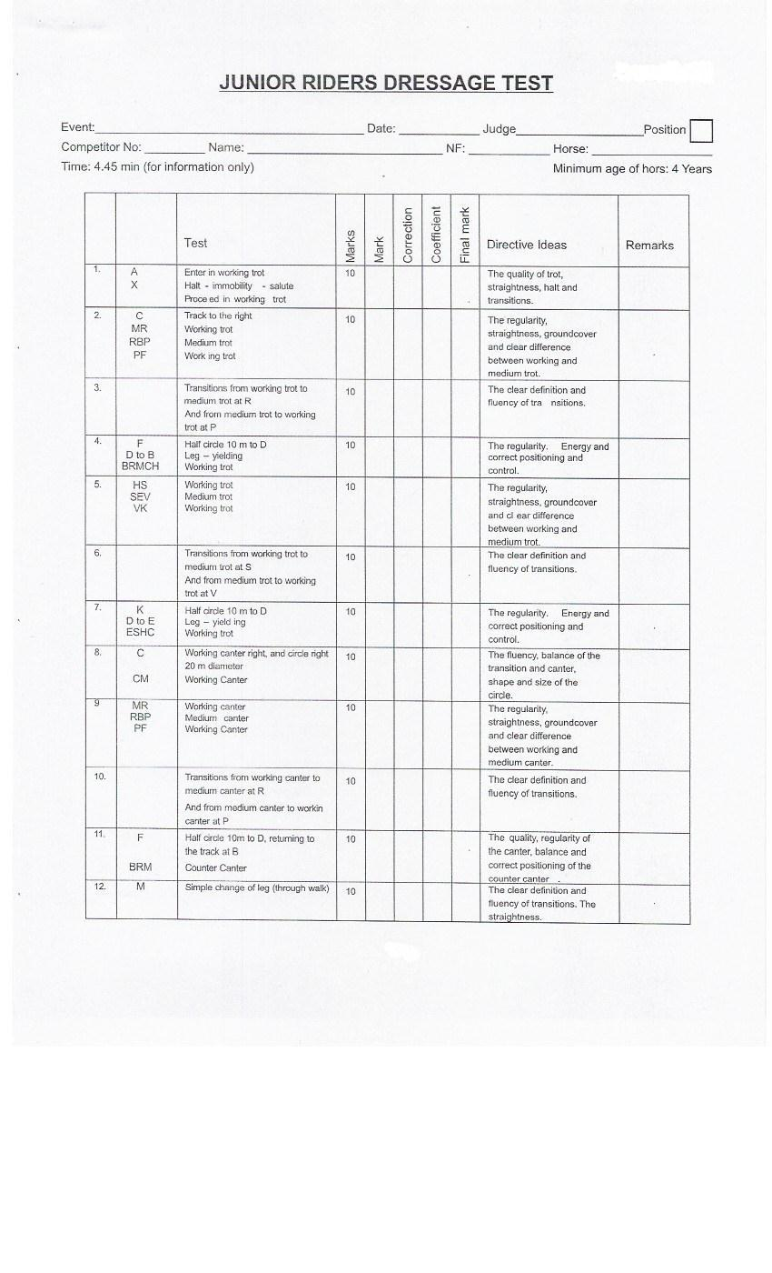
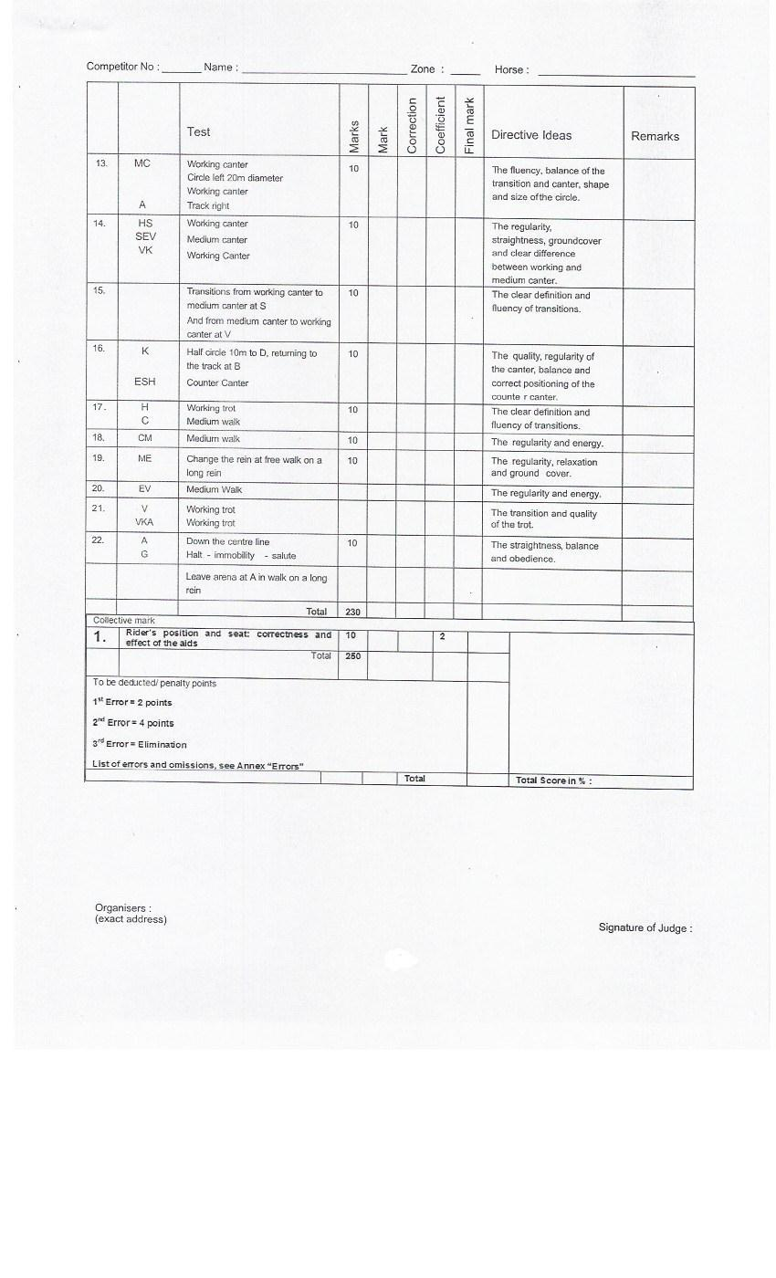
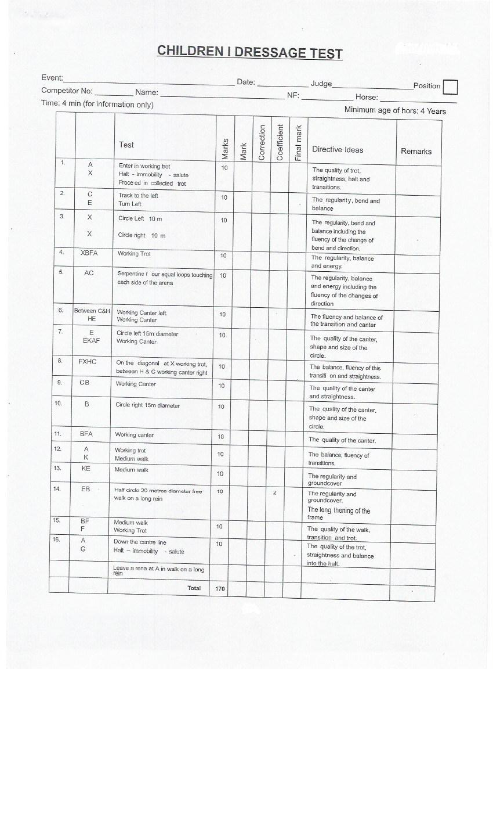
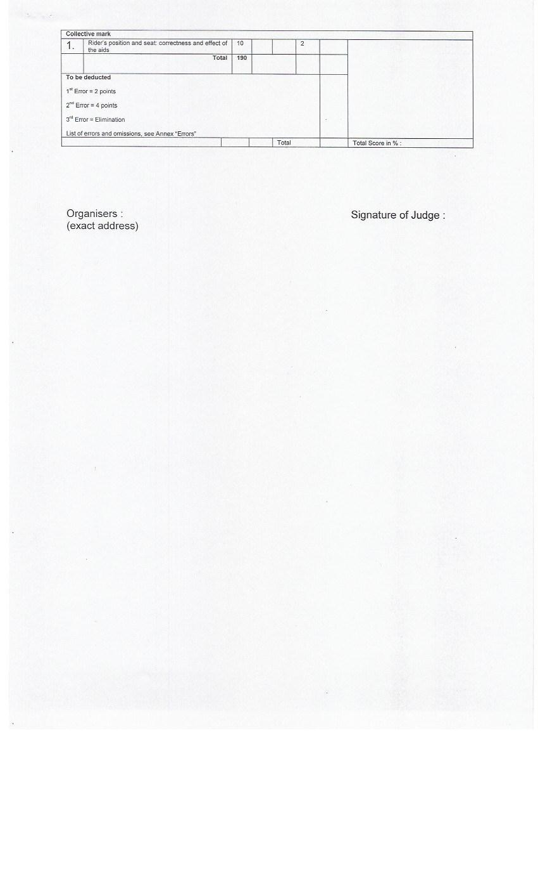
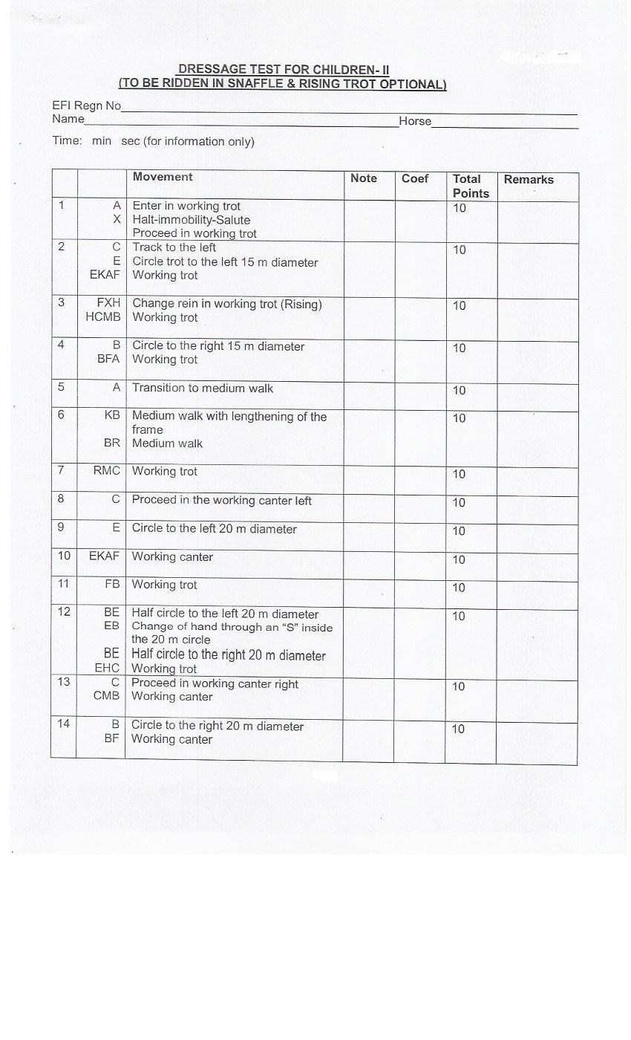
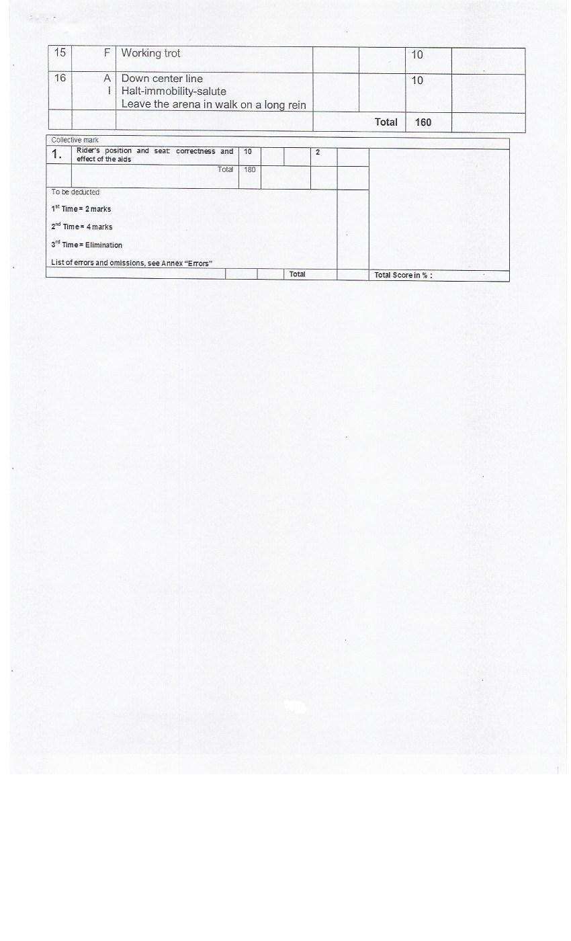

THE 1st REGIONAL EQUESTRIAN LEAGUE (REL)
&
The Second CHETAK Horse Show
5th Oct 2018 – 7th Oct, 2018
ENTRY FORM
Name: _____________________________________________________________________
Father's Name: ______________________________________________________________
Date of Birth: _______________________________________________________________
Address: ___________________________________________________________________
___________________________________________________________________________
Mobile No.: _________________________ e-mail id: _______________________________
Emergency Contact No. _______________________________________________________
Sl.No. | Name of the Event | Tick whichever is applicable |  | Amount
Sl.No. | Name of the Event | REL | CESA | Amount
1
2
3
4
5
6
7
Total:
I declare that the details furnished above are correct to the best of my knowledge.
I undertake no responsibility for any loss, damage or injury that may occur for me / my son. daughter, during the course of the event/s directly or indirectly from accident or any other causes. Neither the CHETAK EQUESTRIAN SPORT ACADEMY will be held responsible for any first aid orother medical treatment provided.

Signature of the Participant Signature of the Parent
(in case of minors)
__________________________________________________________________________________
(for office use only)
Date of Receipt of the Entry Form: Amount Received:
Time of Receipt of the Entry Form: Amount Received by:
Name of Unit/Est/Club: Appendix ‘G’
ENTRY FORM - 1st REGIONAL EQUESTRIAN LEAGUE (REL) / 2nd CHETAK HORSE SHOW - 5th Oct 2018 – 7th Oct, 2018

Sl.  No | Class & Event | Exhibitor | Name of Rider | DOB of Riders  21 yrs & under | Exhibit |  |  |  |  |  | Entry  Fee | Remarks
 |  |  |  |  | Name of Horse | EFI Reg No. | Colour | Sex | Age | EFI Grade | Entry  Fee | Remarks
1
2
3
4
6
7
8
9
10
11
12
13
 |  |  |  |  |  |  | Total Fee
Signature (Manager / Team Captain / Coach) _________________________ Proof of Age, i.e., Birth Certificate, Certificate from School/College should accompany all entries'

